**Discussion 1**

Recall that the solution to a quadratic equation, ax2+bx+c=0,

can be solved by using the formulae

Consider the quadratic equation 5x2+6x+1=0, List the steps for a human being to solve for 𝑥

1. Determine:

* a = 5
* b = 6
* c = 1

1. Calculate:

x = = =

1. Conclude:

x = -0,2 or x = -1

**Discussion 2**

List the steps for a computer to solve problem 1.

1. Input the coefficients a, b, and c.

INPUT a, b, c

1. Calculate the discriminant
2. = 6 * 6 = 36
3. = 36 – 20 = 16
4. Discriminant is 16
5. Is the discriminant negative?

Yes 🡪 Solution: No solution

**No** 🡪 step 4

1. Square root of discriminant

1. Calculate first solution: addition by square root.
2. -6 + 4 = -2
3. Solution 1: x = -0,2
4. Calculate second solution: subtraction by square root.
5. -6 - 4 = -10
6. Solution 2: x = -1

**Discussion 3**

1. What are the functions of each of the units shown in the CPU diagram below.
2. R = register = store values in quickly-accessible place for CU to process
3. CU = control unit = controls the operation of CPU by decoders and logic circuits at the pace of clock cycle = coordinator/chief leader of CPU
4. ALU = arithmetic logic unit = performs arithmetic operations (additions and subtractions) and Boolean operations (true and false)
5. PC = program counter = points the memory location and address
6. IR = instructions register = similar to register but stores instructions instead of values
7. Briefly describe the CPU Instruction Execution Cycle using the example of an instruction A black and white math equation

   Description automatically generated with medium confidence
8. Fetch: CPU fetches instruction from memory, according to direction of Program Counter (PC) and storing it into IR. A black and white math equation

   Description automatically generated with medium confidence
9. Decode: CPU reads and tries to interpret the instruction to do so it knows what it needs to do. This is done by CU, interpreting what the IR says.
10. Execute: ALU does the execution according to the instructions decoded by the CPU.
11. Store: The result is stored back to specific register (for use now) or memory (for use later).
12. Update Program Counter: Program Counter resets to its original state to do the next instruction.

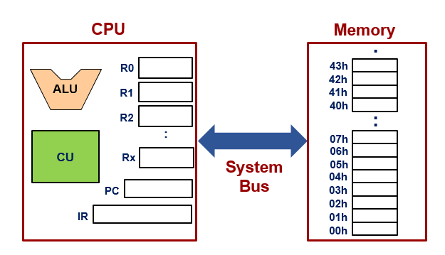

**Discussion 4**

Assume the following:

* The ALU in the diagram above is capable of performing addition, subtraction, multiplication, and square-root operations.
* The result of the ALU computation cannot be immediately stored into the source registers of the computation.

With the fewest possible registers used, show the typical steps that the CPU will use to execute an instruction to compute:

1. Compute , store to R2
2. Copy b to R0
3. Copy b to R1
4. ALU multiplies R0 and R1, stores to R2
5. Compute 4ac, store to R1
6. Copy a to R0
7. Copy 4 to R1
8. ALU multiplies R0 by R1, stores 4a to R3
9. Copy c to R0
10. ALU multiplies R3 by R0, stores 4ac to R1
11. Compute , stores it to R0

ALU subtracts R2 by R1, stores to R0

1. Compute square root, stores it to R1

ALU square-roots R0, stores the root to R1

1. Negate the b, stores it to R2
2. Copy b to R0
3. ALU negates the R0, stores it to R2
4. Compute 2a, stores it to R3
5. Copy a to R0
6. ALU multiplies R0 by 2, stores it to R3
7. Compute the top of fraction, stores it to R0

ALU adds R1 with R2, stores it to R0

1. Compute the whole fraction

ALU divides R0 by R3, stores it to R1

1. CU returns R1 back to memory